Chapter five

Automatic Robots

5.1 History of PLC

During the Industrial Revolution of the 18th-and 19th centuries, many traditionally manual processes were taken over by machines. These early machines relied on gears and pulleys to work and were, by our standards, extremely primitive. The first major breakthrough in the development of control systems came with the invention of electrically powered machines.

The first control systems were developed in early years of the 20th century and used sequential Relay Circuit for machine control. Major technical breakthroughs in its day and still used in some plants today, relay technology enabled machines to work faster and more safely.

Relay circuits performed their job very well, but they required large amounts of floor space, and huge amount of energy. Adding to their drawbacks as the basis for a machine control system, relay circuits also took a long time to install, troubleshoot, and modify. Finally, in the early 1970s, a device was developed to replace sequential relay circuits: the Programmable Logic Control (PLC).
As you will remember from reading about them in Module 24, PLCs are more reliable, faster, more flexible and more efficient than relay-based systems. For example, PLCs are cheaper and easier to wire and maintain than relays. Furthermore, when it comes to troubleshooting, PLCs are much quicker than relays at testing and debugging the program.

PLCs are used in all kinds of industries. In fact, almost any industrial process that uses electrical control needs a PLC. For example, let's assume that when a switch turns on we want to turn a solenoid on for 5 seconds and then turn it off regardless of how long the switch is on. We can do this with a simple external timer. But what if the process included 10 switches and solenoids?
We would need 10 external timers. What if the process also needed to count how many times the switches individually turned on?
We need a lot of external counters. With a PLC, however, we can dispense with those unwieldy timers and counters, and simply program the PLC to count its inputs and turn the solenoids on for the specified time.

5.2 Comparison of PLC with other control system
Table 5.1
C/Cs | Relay systems | Digital Logics | Computers | PLC system
Price Per Function | Fairly Low | Low | High | Low
Physical Size | Bulky | Very Compact | Fairly Compact | Very Compact
Operating Speed | Slow | Very Fast | Fairly Fast | Fast
Noise Immunity | Excellent | Good | Fairly Good | Good
Installation | Time Consuming in Design and Install | Time Consuming in Design | Time Consuming in Programming | Easy in Programming and Install
Complex Operation | None | Yes | Yes | Yes
Easy of Changes | Very Difficult | Difficult | Quite Simple | Very Simple
Easy of Maintenance | Poor-large No. Of Contacts | Poor if ICs Soldered | Poor- several Custom Boards | Good-few Standard Cards

5.3 Advantage of PLCs

The same, as well as more complex tasks can be done with a PLC. Wiring between devices and relay contacts is done in the PLC program. Hard-wiring, though still required to connect field devices, is less intensive. Modifying the application and correcting errors are easier to handle.

It is easier to create and change a program in a PLC than it is to wire and rewire a circuit.
The following are just a few of the advantages of PLCs:-
-Smaller physical size than hard-wire solutions.-
-Easier and faster to make changes.
-PLCs have integrated diagnostics and override functions.
-Diagnostics are centrally available.
-Applications can be immediately documented.
-Applications can be duplicated faster and less expensively.

5.4 FATEK FBS Series PLC

The FATEK FBS Series PLC is a new generation of micro PLC equipped with excellent functions comparable to medium or large PLC, with up to five communication ports. The maximum I/O numbers are 256 points for Digital Input (DI) and Digital Output (DO), 64 words for Numeric Input (NI) and Numeric Output (NO).

The Main Units of FBS are available in three types: MA (Economy Type), MC (High-Performance Type), and MN (High-Speed NC Type). With the combination of I/O point ranges from10 to 60, a total of 17 models are available. Fourteen DI /DO and 12 NI/NO models are available for Expansion Units/Modules.

With interface options in RS232, RS485, USB and Ethernet, the communication peripherals are available with 14 boards and modules.
The FBs-PLC’s design incorporates a “System on Chips“(SoC) developed in-house by Fatek Corporation.

The chip consists of over 120,000 gates which integrates powerful features such as a Central Processing Unit (CPU), Hardware Logic Solver (HLS), five high-speed communication ports, four sets of hardware high-speed counters / timers, four axes of high-speed pulse outputs for NC positioning control (with linear interpolation or dynamic tracking) 16 high-speed interrupts or captured inputs. The FBs represents high functionality and reliability with exceptional value compared to other PLC’s in its class.
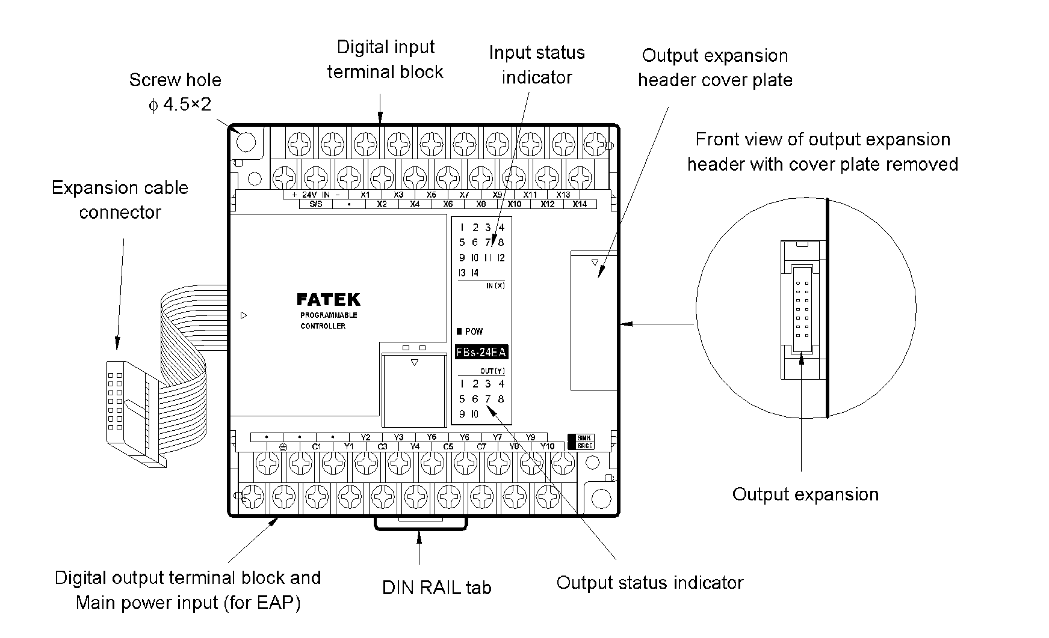

Figure 5.1

5.4.1 Power Supply Wiring

FBS-PLC internally has three kinds of circuit: a 5VDC logic circuit, a 24VDC output circuit, and a 24VDC input circuit.

They are all powered by the built-in power supply of main/expansion units. Expansion modules other than main/expansion units do not contain any power supply and are powered by the power supply inside the main/expansion units or expansion power supply (FBS-EPOW). Main/expansion units or expansion power supply with their model numbers suffixed with “-D” means is operated by DC power source. Otherwise, AC power source is used.

5.4.2 Digital Input (DI) Circuit

The FBS-PLC provides the ultra high speed differential double end 5VDC inputs (i.e., single input with two terminals without common) and the single-end 24VDC inputs which use the common terminal to save terminals. The response speeds of single-end common input circuits are available in high, medium and low. Because the double end input circuit has two independent terminals, it can be connected either in SINK or SOURCE (we will use the term SRCE) for input or in differential input wiring for line driver source. The single-end input circuit can be set to SINK or SRCE type by varying the wiring of the common terminals S/S inside PLC and external common wire of input circuits.

5.4.3 Digital Output (DO) Circuit

The digital outputs of FBS-PLC are available in the following two structures: the 5VDC ultra high speed Line-driver type differential output (i.e., one output occupying two terminals), and the single-end output circuit for saving terminals.

There are three kinds of output device for the single-end output, which are relays, TRIAC and transistors. Since the relay and TRIAC are bilateral, even when used in single-end output, they can serve as SINK or SRCE output. The transistor, however, because of its polarities, after being used as single-end common output, its SINK and SRCE polarities are exactly the opposite (common point Cn of SINK output must connect to negative end of DC power).

Therefore, the product model of transistor output of FBS-PLC for SINK and SRCE is distinct. At the right side of terminal block of FBS-PLC, there is a place for making SINK or SRCE label. The following are labeling examples of:
1- SINK output models in FBS-PLC.
2- Transistor SRCE output model.
3- Relay of TRIAC models with no SINK.
5.4.4 General Features

- User friendly and powerful instruction sets
The FBs-PLC has more than 300 instructions which adopts a user friendly and readable multi-input/multi-output function structure, with multi-input instruction structure can derive many types of functionality which other brands of PLC’s may require the use of many instructions to achieve this.
Also the operation result can be directly sent to internal or external outputs. To increase the program readability, the inputs or outputs for each function instruction have their own mnemonic symbol attached and the content of each operand is also displayed. For high-end applications, such as PLC networking (LINK), PID control and NC positioning etc, the FBs-PLC provides dedicated convenient instructions to assist in program development.

- High-speed timers (HST)
The FBs-PLC is the only PLC in this class providing 0.1mS high-speed timers (the FBs-PLC having one 16-bit and 4 sets of 32-bit HST). Currently, the fastest time base of high speed timers used in other brands of PLC’s is 1mS. By incorporating the interrupt function of the FBs-PLC the accuracy of 0.1mS time base high-speed timer of FBs-PLC is further enhanced and can easily achieve more precise speed detection or can be used as a frequency meter. In most cases, expensive speed detection equipment can be replaced by the economical FBs-PLC.

- Up to 4 sets of high-speed pulse width modulation (HSPWM) output
The SoC inside the FBs-PLC incorporates four sets of hardware high-speed pulse width modulation outputs with a maximum frequency of 184.32 KHz and 18.432 KHz with resolutions of 1% and 0.1%, respectively. Different from the PWM function operated by software alone in other brands of PLC, the hardware driven high-speed PWM in the FBs-PLC operates with high precision and stability which provides the user easy control with precise accuracy.

- User-friendly operating environment
“WinProladder” is the Windows-based ladder diagram programming software for the FBs-PLC. It provides a user-friendly operating environment with editing, monitoring and debugging functions which allows the user to become familiar with the operation of the software in a very short time. The powerful editing function of WinProladder, assisted with keyboard, mouse and on-line help (of ladder instructions and operating guide) greatly reduces programming development time.
Features which can displays the data registers directly in the ladder diagram and provide multiple status pages for monitoring gives the user the ability to monitor and debug easily.

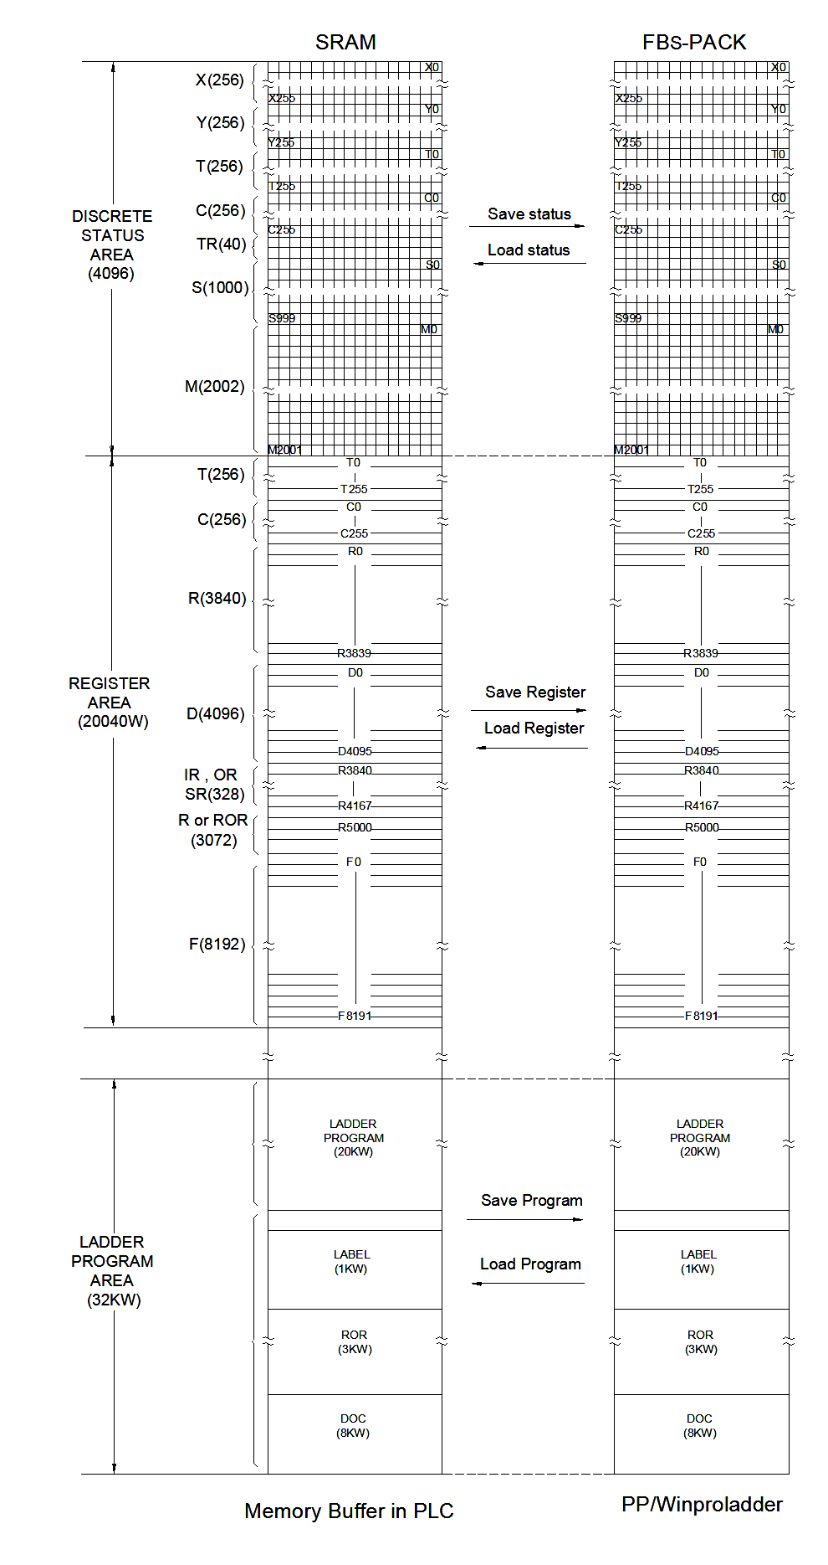
Figure 5.2
FBs-PLC Memory Allocation

5.5 Basic Element of Control System

5.5.1 Switch circuit types

5.5.1.1 Selecting a Switch

There are three important features to consider when selecting a switch:

- Contacts (e.g. single pole, double throw)
- Ratings (maximum voltage and current)
- Method of Operation (toggle, slide, key etc.)

5.5.1.2 Switch Contacts

Several terms are used to describe switch contacts:

- Pole - number of switch contact sets.
- Throw - number of conducting positions, single or double.
- Way - number of conducting positions, three or more.
- Momentary - switch returns to its normal position when released.
- Open - off position, contacts not conducting.
- Closed - on position, contacts conducting, there may be several on positions

For example: the simplest on-off switch has one set of contacts (single pole) and one switching position which conducts (single throw). The switch mechanism has two positions: open (off) and closed (on), but it is called 'single throw' because only one position conducts.

5.5.1.3 Switch Contact Ratings

Switch contacts are rated with a maximum voltage and current, and there may be different ratings for AC and DC. The AC values are higher because the current falls to zero many times each second and an arc is less likely to form across the switch contacts.
For low voltage electronics projects the voltage rating will not matter, but you may need to check the current rating. The maximum current is less for inductive loads (coils and motors) because they cause more sparking at the contacts when switched off.

There are two types of switches that are used in the automatic robots
  - Limit Switches
  - ON-OFF Switches

1-ON-OFF Switches
Single Pole, Double Throw = SPDT
This switch can be on in both positions, switching on a separate device in each case. It is often called a changeover switch. For example, a SPDT switch can be used to switch on a red lamp in one position and a green lamp in the other position.
A SPDT toggle switch may be used as a simple on-off switch by connecting to COM and one of the A or B terminals shown in the diagram. A and B are interchangeable so switches are usually not labeled.
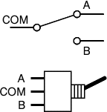
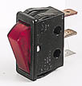

Figure 5.3

2-Limit Switches
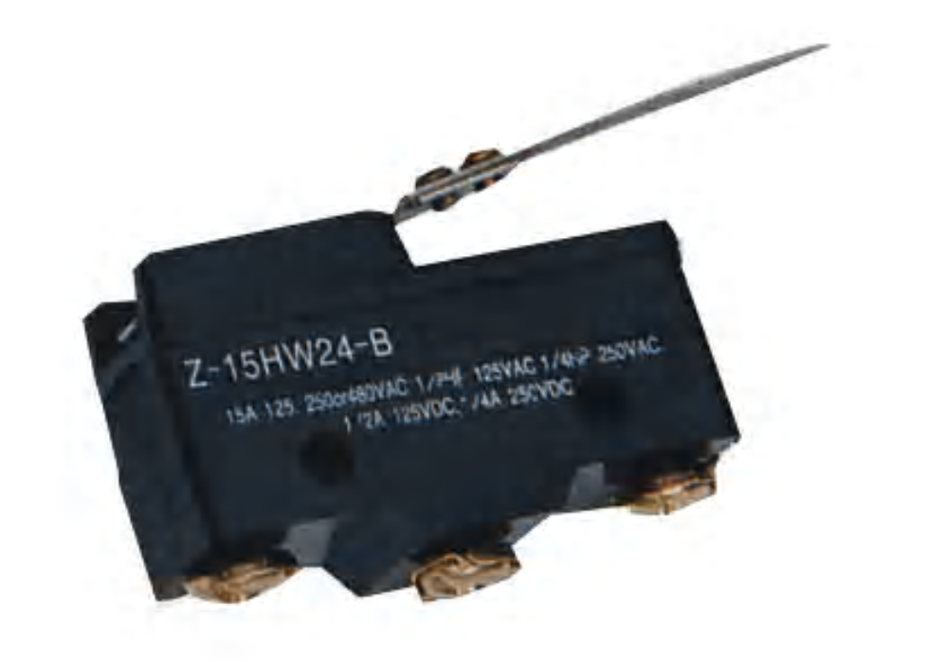
A limit switch is an electro-mechanical device that consists of an actuator mechanically linked to a set of contacts. When an object comes into contact with the actuator, the device operates the contacts to make or break an electrical connection. Limit switches are used in a variety of applications and environments because of their ruggedness, simple visible operation, ease of installation and reliability of operation.
A good starting point for limit-switch selection is contact arrangement. The most common limit switch is the single-pole contact block with one NO and one NC set of contacts; however, limit switches are available with up to four poles.
Limit switches also are available with time-delayed contact transfer. This type is useful in detecting jams that cause the limit switch to remain actuated beyond a predetermined time interval.
Figure 5.4

5.5.2 Sensors

A sensor is a device that measures a physical quantity and converts it into a signal which can be read by an observer or by an instrument. For example, a mercury thermometer converts the measured temperature into expansion and contraction of a liquid which can be read on a calibrated glass tube. A thermocouple converts temperature to an output voltage which can be read by a voltmeter. For accuracy, all sensors need to be calibrated against known standards.
Sensors are used in everyday objects such as touch-sensitive elevator buttons and lamps which dim or brighten by touching the base. There are also innumerable applications for sensors of which most people are never aware. Applications include automobiles, machines, aerospace, medicine, industry, and robotics.
A sensor's sensitivity indicates how much the sensor's output changes when the measured quantity changes. For instance, if the mercury in a thermometer moves 1cm when the temperature changes by 1°, the sensitivity is 1cm/1°. Sensors that measure very small changes must have very high sensitivities.
There are Varity types of sensors that are used in the automatic robots
- Color Mark Sensor
- Proximity Sensor
- Retroflective sensor
- Photo sensors

5.5.2.1 Color Mark Sensor

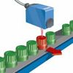
Color Mark Sensor applies the light emitting and receiving principle. It will send out modulating light, receive the reflecting lights from detected object, and distinguish the color or recognize the existence of objects according the intensity of the receiving signals. It can serve for sensor in the automatic control systems for packing machinery, printing machinery, texture and paper making machinery etc and be used with other instruments to detect the existence of the object marked with color code, pattern code, line or others.
Figure 5.5

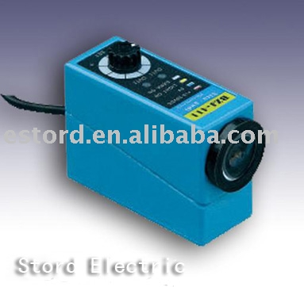
It has the functions of self-locating, recognizing color, rectifying deviation, pattern checking, countering. The sensor applies optical technique, semi-conductor electronic technique, modulation demodulation and has the features of high sensitivity, quick response speed, strong anti-background interference, compact structure and convenient operation etc.

Advantages
1- High precision, several lamp-house can select and with loopy potentiometer
2- Double lamp-house select
3- High detection frequency
4- Simulate output
5- Strong anti-background interference
6- High sensitivity and quick response speed
Figure 5.6

5.5.2.2 Proximity Sensors (Non-Contact Presence Sensors)

Limit switches, discussed earlier are "contact" presence sensors, in that they have to be touched by an object for that object's presence to be sensed. Such contact sensors are often avoided in automated systems because whenever parts touch there is wear and a potential for eventual failure of the sensor. Automated systems are increasingly being designed with non-contact sensors. All of these sensors are actually transducers, but they include control circuitry that allows them to be used as switches. The circuitry changes an internal switch when the transducer output reaches a certain value, and the output of the switch becomes the control systems proximity sensor. Most proximity sensors emit an electromagnetic field or beam and look for changes in the field. The object being sensed is called a target different targets demand different sensors. The three most common types of non-contact sensors in use today are the inductive proximity sensor, the capacitive proximity sensor, and the optical proximity sensor. Each of these fundamental types is explained as follow.
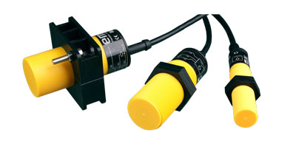
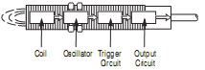

Figure 5.7

1-Inductive proximity sensors
Principles of Operation
Inductive proximity sensors are designed to operate by generating an electromagnetic field and detecting the eddy current losses generated when ferrous and nonferrous metal target objects enter the field. The sensor consists of a coil on a ferrite core, an oscillator, a trigger-signal level detector and an output circuit. As a metal object advances into the field, eddy currents are induced in the target. The result is a loss of energy and smaller amplitude of oscillation. The detector circuit then recognizes a specific change in amplitude and generates a signal which will turn the solid-state output “ON” or “OFF.”
A metal target approaching an inductive proximity sensor (above) absorbs energy generated by the oscillator. When the target is in close range, the energy drain stops the oscillator and changes the output state.

Advantages of Inductive proximity
Inductive proximity switches take advantage of the physical effect of the change in the quality factor in a resonant circuit caused by eddy current losses in conductive materials. The detector circuit inside the sensor detects the losses and when these losses are over the set point, causes the sensor output to change state (if it is a digital output).

2-Capacitive Proximity Sensors

Capacitive proximity sensors sense "target" objects due to the target's ability to be electrically charged. Since even non-conductors can hold charges, this means that just about any object can be detected with this type of sensor.

Inside the sensor is a circuit that:
Uses the supplied DC power to generate AC, to measure the current in the internal AC circuit, and to switch the output circuit when the amount of AC current changes. Unlike the inductive sensor, however, the AC does not drive a coil, but instead tries to charge a capacitor. Remember that capacitors can hold a charge because, when one plate is charged positively, negative charges are attracted into the other plate, thus allowing even more positive.
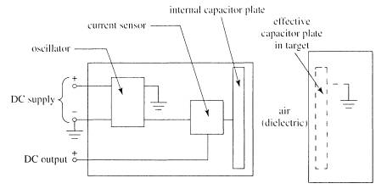
Unless both plates are present and close to each other, it is very difficult to cause either plate to take on very much charge. Only one of the required two capacitor plates is actually built into the capacitive sensor! The AC can move current into and out of this plate only if there is another plate nearby that can hold the opposite charge. The target being sensed acts as the other plate. If this object is near enough to the face of the capacitive sensor to be affected by the charge in the sensor's internal capacitor plate, it will respond by becoming oppositely charged near the sensor, and the sensor will then be able to move significant current into and out of its internal plate.
Figure 5.8

5.5.2.3 Retroflective sensor


The photoelectric sensor identifies transparent objects regardless of shape, color, or compensation. The retroreflective sensor's low hysteresis lets it detect glass bottles, test tubes, or transparent films. The BOS 6k is designed with the emitter and receiver on the same optical axis for a higher switching accuracy. A built-in polarizing filter suppresses interference. A pulsed, visible red light increases ambient light rejection.
Figure 5.9

5.5.2.4 Comparison among different sensors

Table 5.2
Sensors | Advantages | Disadvantages | Applications
Limit Switch | -High Current Capability  -Low Cost  -Familiar | -Require Physical Contact  -Very Slow Response  -Contact Bounce | -Interlocking  -Basic End Travel Sensing
Photoelectric | -Senses all kinds of Material  -Long Life  -Largest Sensing Range  Very Fast Response Time | -Lens Subject to Contamination  -Sensing Range Affect by Color and Reflectivity | -Packing  -Material Handling  -Parts Detection
Inductive | -Resistant to Harsh Environments  -Very Predictable  -Long Life  -easy to Install | -Distance Limitations  -Senses Metal Only | -Industrial and Machines  -Machine Tools
Capacitive | -Can Detect Non-Metallic  -Detects Through Some Containers | -Very Sensitive to Extreme Environmental Changes | -Level Sensing

5.6 Automatic Robots

In order to achieve the objectives of ROBOCON contest we construct two automatic robots to catch white and yellow butter.
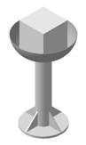
5.6.1 Automatic Robot 1

The function of this robot is to track white line on the ground until reach Side Bowl then catch the white butter and then hold it into the air above the rim.
Figure 5.10
White butter

Control Part
To understand the method of operation we have to discuss the following items
  - Motion
  - Rotation
  - Arm control

5.6.1.1 Motion Control

If the auto machine moved without any control, the robot will deviate and will not reach its destination.
The solution is to make correction for the deviation using two color mark sensor to track white line on the ground.
The two sensors (shown in figure 5.11) lie on both sides of white line. So that if robot deviated to right. The right sensor detects that then robot correct this situation until reach proper position and visa versa.

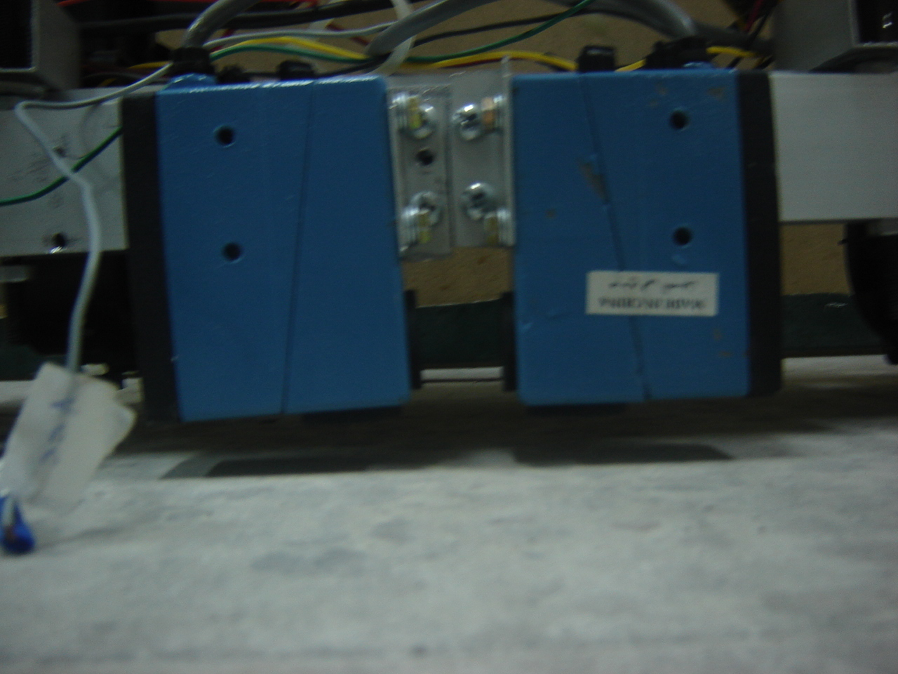

Figure 5.11
Color Mark Sensor

Robot can correct the deviation by controlling motors speed by means of Pulse Width Modulation (PWM).

What is Pulse width modulation?
Pulse-width modulation control works by switching the power supplied to the motor on and off very rapidly. The DC voltage is converted to a square-wave signal, alternating between fully on (nearly 12V) and zero, giving the motor a series of power "kicks".

If the switching frequency is high enough, the motor runs at a steady speed due to its fly-wheel momentum.

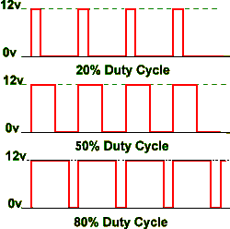
By adjusting the duty cycle of the signal (modulating the width of the pulse, hence the 'PWM') i.e., the time fraction it is "on", the average power can be varied, and hence the motor speed.

Figure 5.12 shows three different PWM signals. Figure 5.12 shows a PWM output at a 20% duty cycle. That is, the signal is on for 20% of the period and off the other 80%. Figure 5.12 show PWM outputs at 50% and 80% duty cycles, respectively. These three PWM outputs encode three different analog signal values, at 20%, 50%, and 80% of the full strength. If, for example, the supply is 9V and the duty cycle is 20%, a 0.8V analog signal results.
Figure 5.12
In order to use PLC to drive motors relay board (shown in figure 5.13) must be used to isolate PLC from unwanted reflected power from motors.
Relays connected to both terminals of each motor as Half H Bridge circuit to enable the rotation of rotor of each motor in both directions.
Relay board connected to motors and PLC pins via ATX socket.
The purpose of the socket is to:
- Collect wires from relay board at on place.
- Make replacing board with another one easier.
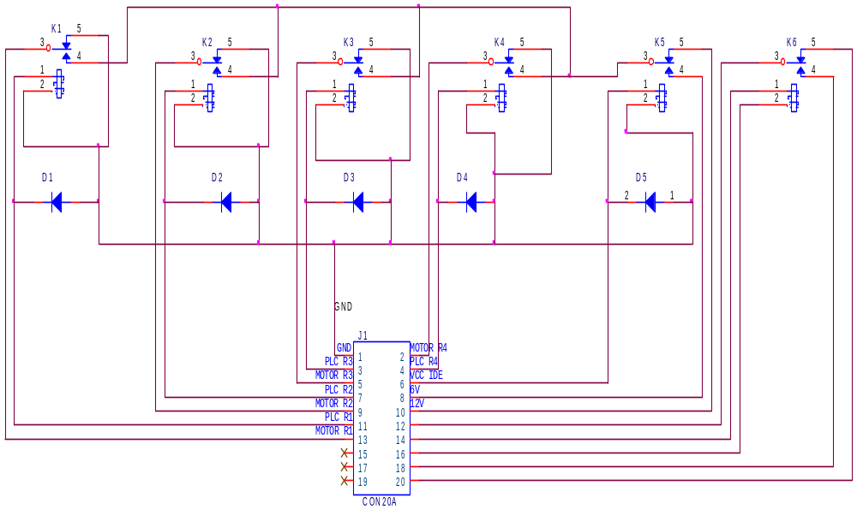

Figure 5.13
5.6.1.2Rotation control

To allow robot rotate nine tee degree to left by rotating right motor in the forward direction while left motor in the reverse direction, This done for a specific time period.
After rotation color sensors must find white line again.

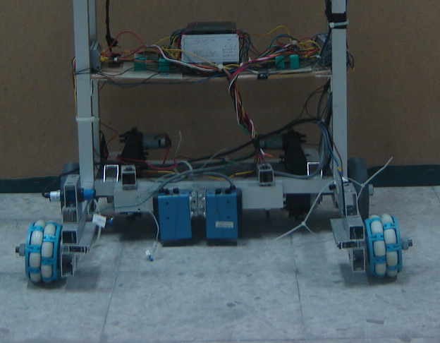
5.6.1.3 Arm control

After rotation the robot moves straightly where it will stop when Side Bowel gets between two parts of Retroflective sensor which shown in figure 5.14.

Then arm begin to get down until it hits limit switches which enables closing the arm for a specific period of time until catch white butter then the arm raised until another limit switch recognize that arm reaches maximum allowed height.
Retroflective sensor
Figure 5.14

After auto machine catch white butter it must go backward for one second to prevent robot from touching Side Bowel.
Methods of Wiring
Terminal blocks are used as intermediate stages between
- PLC and relay board
- PLC and power supply points
- PLC and sensors
- Relay board and motors

This is necessary to make wiring among these elements easier. This gives more than just the appearance of quality; it saves time and space, enhances design capabilities and provides a centralized connect- disconnect area where external and/or internal wiring can be connected quickly and efficiently. At the same time, the DIN concept allows designers to take advantage of constant advances in terminal block technology. They distribute power and ground. Whatever the application: control systems, instrumentation, automation—terminal blocks can help you create it and keep it as up-to-date as tomorrow.
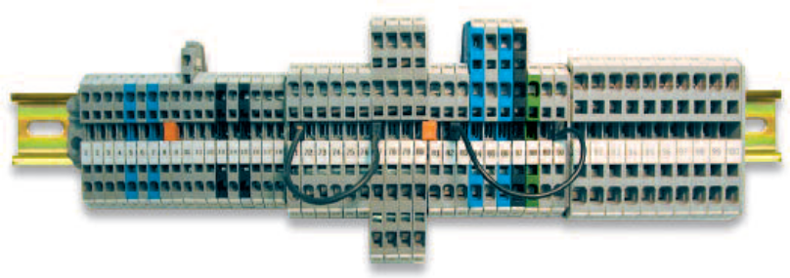

Figure 5.15
Terminal blocks

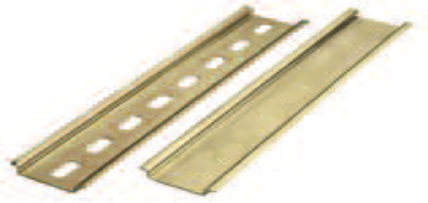
Terminal blocks are collected on bar called OMEGA bar as shown in the following figure.5.16

Figure 5.16
OMEGA bar

Figure 5.17 shows a number of pins that used to connect more than one terminal block together in order to act as one connection point.
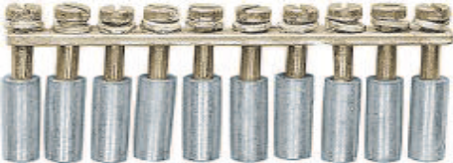

Figure 5.17

5.6.2 Automatic Robot 2

To understand the method of operation we have to discuss the following items
  - Motion & Rotation
  - Arm control

5.6.2.1 Motion &rotation
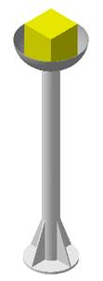
The function of this robot is to move from the start zone until reach Central Bowl then stopped near the common area at which manual robot merges with it. Then manual robot should raise automatic machine to specific height at which automatic machine catch the yellow butter and then hold it into the air above the rim.

The manual robot may get down automatic machine and then return to collect pots and cheeses.

Relay board also is the same as it for automatic robot 1
Except that it has larger number of relays since this robot contains larger number of motors.
Figure 5.18
Yellow butter

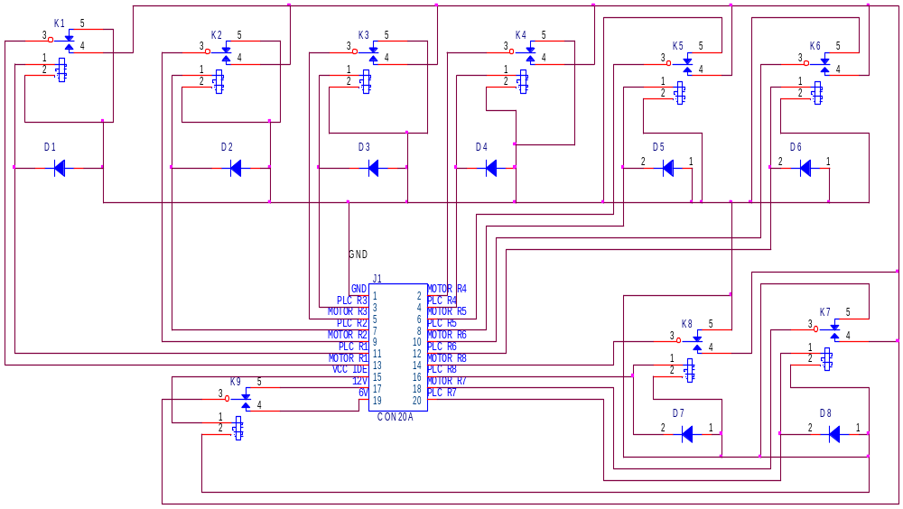

Figure 5.19 drive motors relay board

5.6.2.2 Arm control

After rotation, robot moves straightly until count a specific number of lines then reduce its speed until one of two proximity sensors lies in the front side of robot sense barrier.
At this moment robot stopped while gripper rose to its normal position.
After manual machine handle the automatic robot, it will raise the auto machine above yellow butter then get down until butter gets between two parts of retroflective sensor. Then arm is closed until catch the butter
After mission is completed manual machine are separated from automatic robot then goes to collect another pots and chesses.
5.7 FBs-PLC Instruction Lists

Instruct-ion | operand | symbol | Function description | Execution  time | Instruction type
ORG | X ,Y,M  S,T,C |  | Starting a network with a normally open (A)  ORG contact | 0.33uS | Network  starting  instructions
ORG NOT | X ,Y,M  S,T,C |  | Starting a network with a normally closed  (B) contact | 0.54uS | Network  starting  instructions
ORG TU | X ,Y,M  S,T,C |  | Starting a network with a differential up (TU) contact | 0.54uS | Network  starting  instructions
ORG TD | X ,Y,M  S,T,C |  | Starting a network with a differential down (TD) contact | 0.33uS | Network  starting  instructions
OUT | X,Y,M,  S,T,C |  | Send result to coil | 0.33uS  ¦  1.09uS | Coil output  instruction
OUT NOT | X,Y,M,  S,T,C |  | Send inverted result to coil | 0.33uS  ¦  1.09uS | Coil output  instruction
SET | X,Y,M,  S,T,C |  | Set a coil | 0.33uS  ¦  1.09uS | Coil output  instruction
RST | X,Y,M,  S,T,C |  | Reset a coil | 0.33uS  ¦  1.09uS | Coil output  instruction
5.7.1 Contact and coils instructions
Table 5.3
5.7.2 Sequential instructions

5.7.2.1 Timer

Operand: T

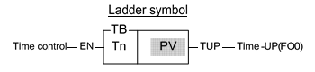
Ladder symbol:
1-Tn: timer number
2-PV: Preset value of the time

Figure 5.20
Function description:

1-When the time control “EN” is 1, the timer will start timing (the current value will accumulate from 0) until “Time Up” (i.e. CV?PV), then the Tn contact and TUP (FO0) will change to 1. As long as the timer control “EN” input is kept as 1, even the CV of Tn has reached or exceeded the PV, the CV of the timer will continue accumulating (with M1957 = 0) until it reaches the maximum limit (32767). The Tn contact status and flag will remain as 1 when CV? PV, unless the “EN” input is 0. When “EN” input is 0, the CV of Tn will be reset to 0 immediately and the Tn contact and “Time Up” flag TUP will also change to 0

2-If the FBS-PLC OS version is higher than V3.0 (inclusive), the M1957 can be set to 1 so the CV will not accumulate further after “Time Up” and stops at the PV value. The default value of the M1957 is 0, therefore the status of M1957 can be set before executing any timer instruction in the program to individually set the timer CV to continue accumulating or stop at the PV after “Time Up”.

Example:
The preset value (PV) shown in example 1 is a constant which is equal to 1000. This value is fixed and can not be changed once programmed. In many circumstances, the preset time of the timers needs to be varied while PLC running. In order to change the preset time of a timer, can first use a register as the PV operand (R or WX, WY...) and then the preset time can be varied by changing the register content. As shown in this example, if set R0 to100, then T becomes a 10S Timer, and hence if set R0 to 200, then T becomes a 20S Timer.
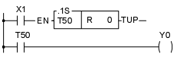

Figure 5.21.A

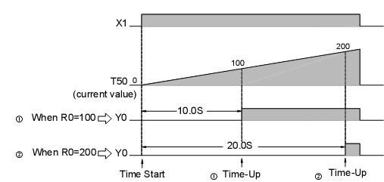

Figure 5.21.B
5.7.2.2 Counter

Operand: C
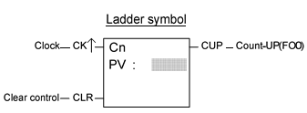
Ladder symbol:
1-Cn: The Counter number.
2-PV: Preset value.

Figure 5.22
Function description:

1-When "CLR" is at 1, all of the contact Cn, FO0 (CUP), and CV value of the counter CV are cleared to 0 and the counter stops counting. When "CLR" is at 0, the counter is allowed to count up. The Counter counts up every time the clock "CK?" changes from 0 to 1 (adds 1 to the CV) until the cumulative current value is equal to or greater than the preset value (CV>=PV), the counter "Count-Up" and the contact status of the counter Cn and FO0 (CUP) changes to 1. If the input status of clock continues to change, even the cumulative current value is equal and greater than the preset value, the CV value will still accumulate until it reaches the up limit at 32767 or 2147483647. The contact Cn and FO0 (CUP) stay at 1 as long as CV>=PV unless the "CLR" input is set to below).

2-If the FBS-PLC OS version is higher than V3.0 (inclusive), the M1973 can set to 1 so the CV will accumulate further after “Count Up” and stops at the PV. M1973 default value is 0, therefore the statuM1973 can be set before executing any counter instruction in the program to individually set the cou below).CV to continue accumulating or stops at the PV after “Count Up”

Example:
Like a timer, if the PV of a counter is changed to a register (such as R, D, and so on), the counter will use the register contents as the counting PV. Therefore, only need to change the register contents to change the PV of the counter while PLC is running. Below is an example of a 32-bit counter that uses the data register R0 as the PV (in fact it is the 32-bit PV formed by R1 and R0).
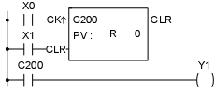
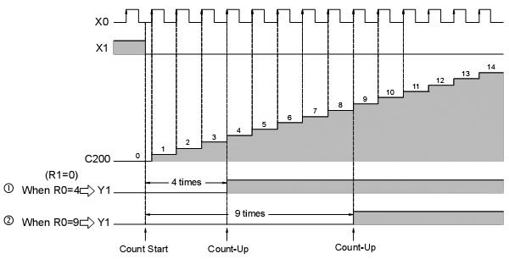

Figure 5.23

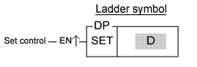
5.7.2.3 SET

Operand: SET D P
Ladder symbol:
D: destination to be set (the number of a coil or a register)
Figure 5.24

Function description:
When the set control "EN" =1 or "EN?" (P instruction) is from 0 to 1, sets the bit of a coil or all bits of a register to 1.
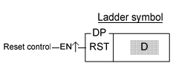
5.7.2.4 RESET

Operand: RST D P
Ladder symbol:
D: destination to be set (the number of a coil or a register)
Figure 5.25

Function description:
When the reset control "EN" =1 or "EN?" (P instruction) from 0 to 1, resets the coil or register to 0.

5.7.2.5 TABLE TO REGISTER MOVE

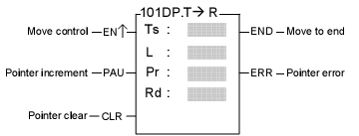
Operand: FUN101 D T-R
Ladder symbol:
Ts: source table starting register
L: length of source table
Pr: Pointer register
Rd: Destination register
Ts, Rd may combine with V, Z, and P0-P9 to serve indirect address application
Figure 5.26

Function description:
1-When move control "EN" = 1 or "EN?" (P instruction) transition from 0 to 1, the value of the register Tspr specified by pointer Pr within source table Ts (length is L) will be written into the destination register Rd. Before executing, this instruction will first check the input signal of pointer clear "CLR". If "CLR" is 1, it will first clear Pr and then carry out the move operation. After completing the move operation, it will then check the value of Pr.

2-If the Pr value has already reached L-1 (point to the last register in the table), then it sets the move-to-end flag to 1, and finishes executing of this instruction. If Pr is less than L-1, it checks the status of "INC". If "INC" is 1, hen it will increase Pr and finish the execution of this instruction. Besides, pointer clear "CLR" can execute independently and is not influenced by other inputs.

3-The effective range of the pointer is 0 to L-1. Beyond this range the pointer error "ERR" will be set to 1 and this instruction will not be carried out.

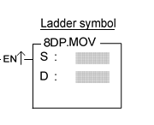
5.7.2.6 MOVE

Operand: FUN 8 D MOV
Ladder symbol:
S: source register number
D: Destination register number
The S, N, D may combine with V, Z, and P0-P9 to serve indirect addressing
Figure 5.27

Function description:
Move (write) the data of S to a specified register D when the move control input "EN" =1 or "EN?" ( P instruction) from 0 to 1.

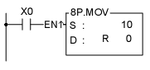
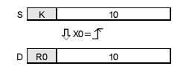

Figure 5.28

5.7.2.7 PULSE WIDTH MODULATION

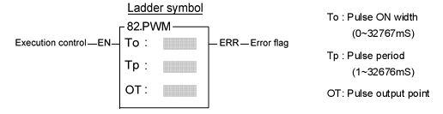
Operand: FUN 82 PWM
Ladder symbol:
To: Pulse ON width (0~32767ms)
Tp: Pulse period (1~32676ms)
OT: Pulse output point
Figure 5.29
Function description:
1-When execution control "EN" = 1, will send the pulse to output point OT with the "ON" state for To ms and period as Tp. OT must be a transistor output point on the main unit. When "EN" is 0, the output point will be OFF.

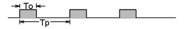
Figure 5.30

2-The units for Tp and To are mS, resolution is 1 mS. The minimum value for To is 0 (under such case the output point OT will always be OFF), and its maximum value is the same as Tp (under such case the output point OT will always be on). If To > Tp there will be an error, this instruction will not be carried out, and the error flag "ERR" will set to 1.

3-This instruction can only be used once.

5.7.3 Step Instruction Description

1-Structured programming design is a major trend in software design. The benefits are high readability, easy maintenance, convenient updating and high quality and reliability. For the control applications, consisted of many sequential tasks, designed by conventional ladder program design methodology usually makes others hard to maintain. Therefore, it is necessary to combine the current widely used ladder diagrams with the sequential controls made especially for machine working flow. With help from step instructions, the design work will become more efficient, time saving and controlled. This kind of design method that combines process control and ladder diagram together is called the step ladder language.

2-The basic unit of step ladder diagram is a step. A step is equivalent to a movement (stop) in the machine operation where each movement has an output. The complete machine or the overall sequential control process is the combination of steps in serial or parallel. Its step-by-step sequential execution procedure allows others to be able to understand the machine operations thoroughly, so that design, operation, and maintenance will become more effective and simpler.

5.7.3.1 Introduction of Step Instructions: STP, FROM, TO and STPEND
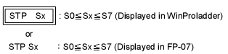

Figure 5.31

This instruction is the initial step instruction from where the step control of each machine process can be derived. Up to 8 initial steps can be used in the FBs series, i.e. a PLC can make up to 8 process controls simultaneously. Each step process can operate independently or generate results for the reference of other processes.

Example 1? Go to the initial step S0 after each start (ON)
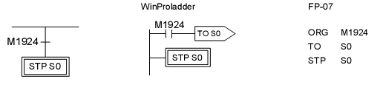
Figure 5.32

Example2
Each time the device is start to run or the manual button is pressed or the device is malfunction, then the device automatically enters the initial step S0 to standby.
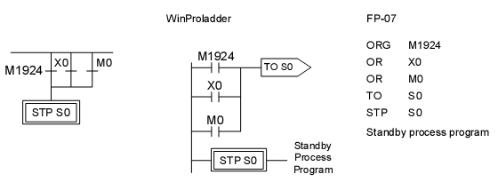
Figure 5.33

X0: Manual Button, M0: Abnormal Contact.

5.7.3.2 Description

1- STP instruction

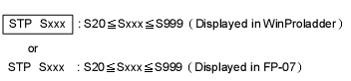
Figure 5.34

This instruction is a step instruction; each step in a process represents a step of sequence. If the status of step is ON then the step is active and will execute the ladder program associate to the step.

2- FROM instruction
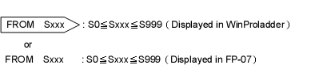

Figure 5.35
The instruction describes the source step of the transfer, i.e. moving from step Sxxx to the next step in coordination with transfer condition.

3-TO instruction
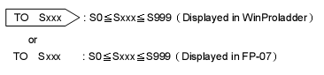

Figure 5.36

This instruction describes the step to be transferred to.

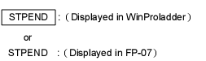
4-STPEND instruction

Figure 5.37

This instruction represents the end of a process. It is necessary to include this instruction so all processes can be operated correctly.

A PLC can have up to 8 step processes (S0~S7) and is able to control the simultaneously. Therefore, up to 8 STPEND instructions can be obtained.

5.7.3.3 Notes for Writing a Step Ladder Diagram

- In actual applications, the ladder diagram can be used together with the step ladder.

- There are 8 steps, S0~S7, that can be used as the starting point and are called the “initial steps”.

- When PLC starts operating, it is necessary to activate the initial step. The M1924 (the first scan ON signal) provided by the system may be used to activate the initial step.

- Except the initial step, the start of any other steps must be driven by other step.

- It is necessary to have an initial step and the final STPEND instruction in a step ladder diagram to complete a step process program.

- There are 980 steps, S20~S999, available that can be used freely. However, used numbers cannot be repeated. S500~S999 are retentive (The range can be modified by users), can be used if it is required to continue the machine process after power is off.

- Basically a step must consist of three parts which are control output, transition conditions and transition targets.

- MC and SKP instructions cannot be used in a step program and the sub-programs. It’s recommended that JMP instruction should be avoided as much as possible.

- If the output point is required to stay ON after the step is divergent to other step, it is necessary to use the SET instruction to control the output point and use RST instruction to clear the output point to OFF.
- Looking down from an initial step, the maximum number of horizontal paths is 16. However, a step is only allowed to have up to 8 branch paths.

- When M1918=0(default), if a PULSE type function instruction is used in master control loop (FUN 0) or a step program, it is necessary to connect a TU instruction before the function instruction.

Example:

1. When ON, the initial step S0 is ON. If X0 is ON, then Y0 will be ON.

2. When S0 is ON: a. if X1 is ON, then step S20 will be ON and Y1 will be ON.

        - b. if X2 is ON, then step S21 will be ON and Y2 will be ON.

        - c. if X3 is ON, then step S22 will be ON and Y3 will be ON.

        - d. if X1, X2 and X3 are all ON simultaneous, then step S20 will have the priority to be ON first and either S21 or S22 will not be ON.

        - e. if X2 and X3 are ON at the same time, then step S21 will have the priority to be ON first and S22 will not be ON.

3. When S20 is ON, if X5 and X7 are ON at the same time, then step S23 will be ON, Y4 will be ON and S20 and Y1 will be OFF.

4. When S21 is ON, if X4 is ON, then step S0 will be ON and S21 and Y2 will be OFF.

5. When S22 is ON, if X6 and X7 are ON at the same time, then step S23 will be ON, Y4 will be ON and S22 and Y3 will be OFF.

6. When S23 is ON, if X8 is ON, then step S0 will be ON and S23 and Y4 will be OFF.

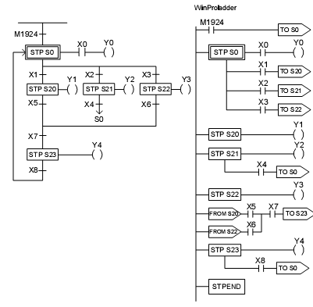
Figure 5.38

5.8 automatic programs

5.8.1 First automatic robot program

And now after we have discuss all the possible instruction that will be used in our program

We will give a brief introduction to our program and the tasks, movements and motion.

- Move forward

- Adjust any drift by using PULSE WIDTH MODULATION (PWM)

- Count the number of the vertical line

- Turn and move forward again

- Moving forward until reach the tower then stop

- Open the arm

- Move down the arm

- Close the arm

- Move up the arm

- Move backward then stop

We will begin now to explain the program sequence and we will exert all our effort to make it simple and obvious

1-As the PLC go in the run mode the contacts (M1924 , M0) will be enabled so the move instruction will enabled and the constant values will be moved to the registers and the step S0 will be called .

2-When the start button X0 is on the steps S21 AND S29 will be called and enabled.

3-Step S21is responsible for enable M21 which is responsible to move the robot in the forward direction so it will enable Y1 and Y3 and the robot will begin to move forward.

4-As the robot begin to move forward as the two color mark sensor X2 AND X3sense the vertical white line simultaneously the counter C2 will be enabled and the count is begun.

5-As the count value reach 2 the coil M5 will be enabled and call the step S23 which will be enabled and enable the coil M9 which will be used to enable the and disable step S21 and then M9 is used to enable the coil Y0 which will be used to rotate the left wheel to the forward AND Y1 which will be use to rotate the right wheel in the backward direction and so the robot will rotate around its axes.
6-The contact of M9 is used also to enable the timer T2 and when this timer reach its predetermined value its contact will enabled and then it will used to call the step S21 and disable the step S23 and the robot will stop the rotate process and begin to move forward again .

7-as the robot reach the tower the auto reflector sensor which is connected to the physical input X7 will sense the tower and then it enable the step S24 which will enable the output coil Y5 which will be used to open the arm and it also disable the step S21 .the is still opened until the limited sensor that connect to the input X5 is enabled.

8-At this time the step S25is enabled which will enable the output coil Y6 which will be used to move down the arm and also it disable the step S24 which lead to stop opening the arm.

9-The arm is still move down until the limited sensor that connected to the input X6 is enabled at this tie it will enable the step S26 which will be used to enable the output coil Y7 which will be used to close the arm and it also enable the timer T3 .

10-As the output signal of the timer T3 is activated the step S27 will be enabled and so it enable the output coil Y8 which will be used to move up the arm and it also disable the step S26 and stop closing the arm .

11-The arm is still move up until the input X6 is enabled at this time it enable the step S28 which will enable the coil M20 which will be used to enable the output coil Y0AND Y1 which will be used to move the robot backward and also enable the timer T4.

12-As the output signal from the timer T4 is enabled the step S28 is disabled and the step S0 is enabled and the program is stopped and the robot has achieved its task successfully.

13-When there is drift in the movement this drift will be detected by the color mark sensor which attached to the physical input X2 AND X3 and these action will be done
14-If the robot drift to the right direction X2 will be enabled but X3 isn’t enabled and so X2 will be enabled in the program and the step S22 will be enabled and the closed contact of X2 will be opened and the opened contact will be closed and so the branch that contain X2, M21AND Y4 will be activated.

15-As the step S22 is called the coil M3 will be enabled and the pulse width modulation instruction is enabled.

16-Also as the X2 is on the M2 coil will be enabled and it enable the timer T20 which will be used to enable the table to register instruction which will used to change the width of the on pulse the directed to the output coil Y2 .

17-As the signal of X2 is vanish the step S22 is disabled and step S29 is enabled it mean that the drift is fixed and the robot begin to move in the desired direction.

18-These steps are repeated as the contact X2 is enabled at any time the drift occur.

19-When the robot drift to left X3 will be enabled and the same previous steps will be executed but on the physical output Y3.
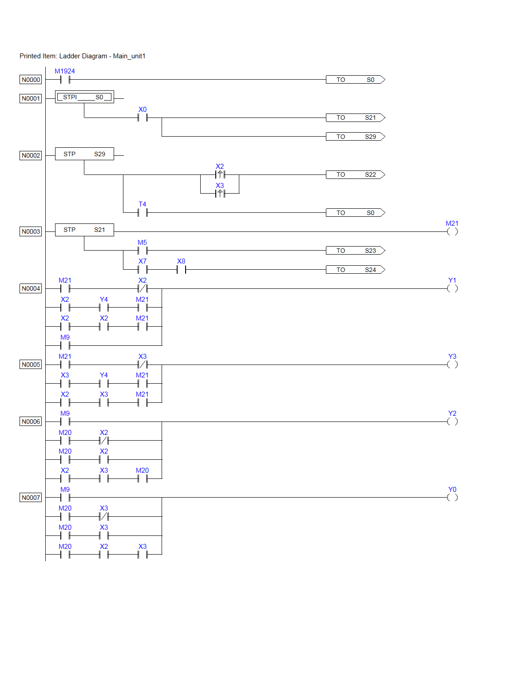
Figure 5.39.A
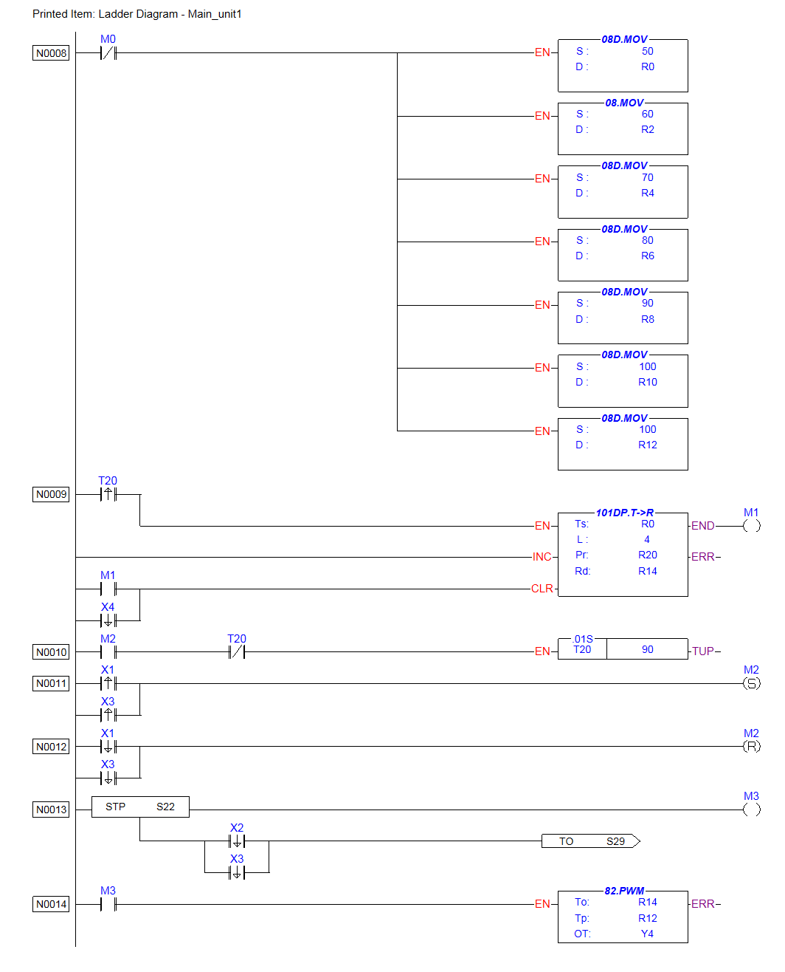
Figure 5.39.B
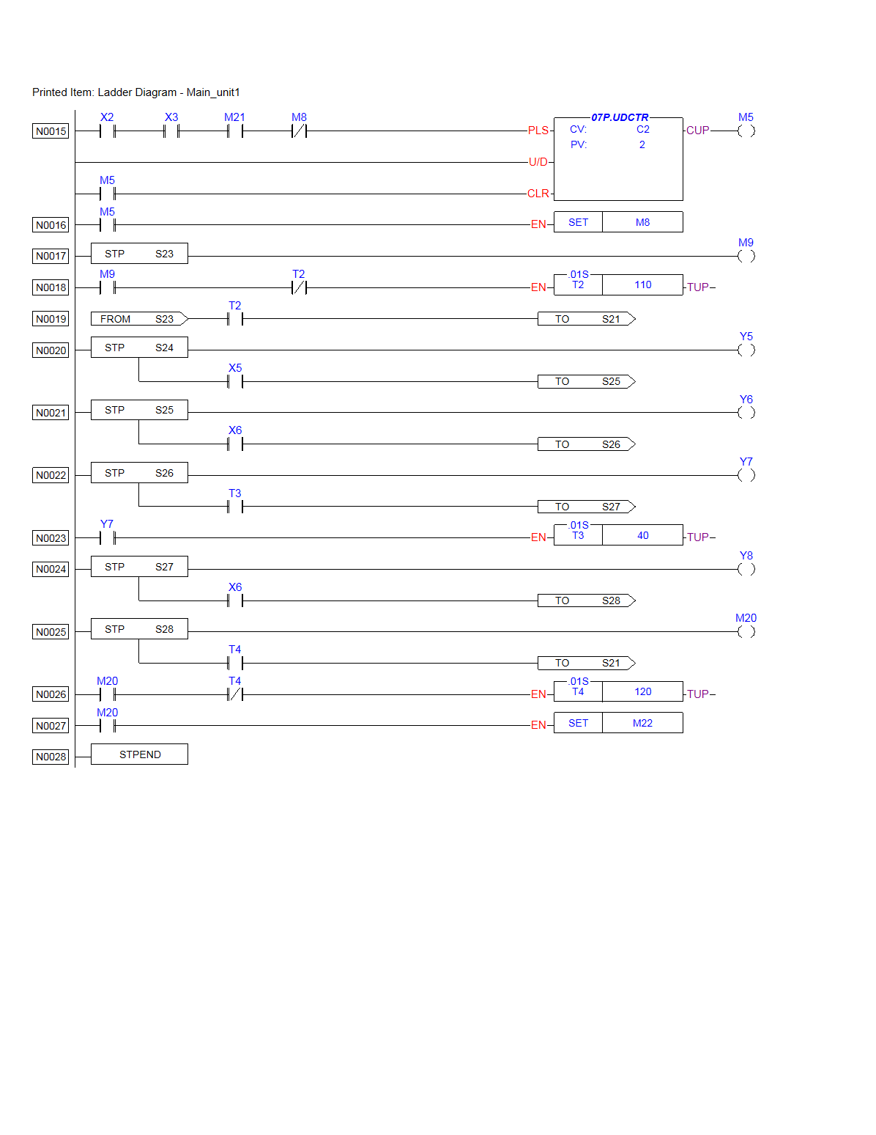
Figure 5.39.C

5.8.2 Second automatic robot program

We will also give a brief explanation about the task, motion and special movement:

- Move forward (step S21)

- Adjust the drift during the motion (STEP S23)

- Count the white vertical line(STEAP 21)

- Move backward (STEP S24)

- Rotate around the robot axes (STEP S25)

- Move to side (STEP S26)

- Move forward (STEP S21)

- Stop at the wood barrage

- extension of the arm (step S27)

- Open the arm(STEP S28)

- Carried by the manual

- Close the arm(STEP S30)

- Carry the block

And now we will try to explain the program of this robot and we will try to make it simple and easy to perception and we will try to reveal any ambiguous things and explain it in details but please before read the program you have to read the instruction that we have discussed before and you will not find any problem when you read this or any PLC program

1-as the PLC go in the run mode (M1924 & M0) will be activated so the move instruction will enabled and the constant values will be moved to the registers and the step S0 will be called .

2-When the start button X0 is on the steps S21 AND S22 will be called and enabled

3-Step S21is responsible for enable M21 which is responsible to move the robot in the forward direction so it will enable Y7 and Y8 and the robot will begin to move forward

4-As the robot begin to move forward as the two color mark sensor X2 AND X3 sense the vertical white line simultaneously the counter C2 will be enabled and the count is begun .

5-As the count value reach 7 the coil M5 will be enabled and call the step S24 which will be enabled and enable the coil M8 which will be used to enable S24 the and disable step S21 ,M8 will be used to enable the output coil Y11 AND Y12 which responsible for move the robot in backward direction ,M8 will enable the timer T2 which when its output signal enable it will lead to disable step S24 and enable step S25 which will enable the coil M4 which will also enable the timer T5 and it used to enable the out put coil Y7 and Y12which will lead to rotate the right wheel in the forward direction and the left wheel in the reverse direction and so the robot rotate around it self .

6-when the output signal from the timer is enabled the rotate will stop and the step S25 is disabled and the step S26 is enabled which will enable the coil M10 which will enable the output coil Y9 which will lead to move the robot to the side until the color mark sensor X2 is enabled then the step S26 is disabled and the step S21 is enabled. which will lead the robot to move forward again when the proximity sensor X4 OR X5 is enabled the step S21 is disabled and the step S27 is enabled and enable the output coil Y1 which will be used to extend the arm until limit sensor X6 is enabled .

7-it will used to disable the step S27 and enable S28 which will be used to enable the output coil Y2 which will be used to open the arm until the limited sensor X7 is enabled and it disable the S28 and enable S29 the program will stay at this step until the manual robot carry it and direct it to the tower at which the yellow block is found.

8-when the auto reflector sensor is enabled the step S30 is enabled and the arm begin to be closed and it also enable the timer T6 and when the output signal of the timer is enabled the S30 will be disabled and the S0 will be enable and the program stop.

9-When there is drift in the movement this drift will be detected by the color mark sensor which attached to the physical input X2 AND X3 and these action will be done

10-If the robot drift to the right direction X2 will be enabled but X3 isn’t enabled and so X2 will be enabled in the program and the step S23 will be enabled and the closed contact of X2 will be opened and the opened contact will be closed and so the branch that contain X2, M21AND Y13 will be activated.

11-As the step S22 is called the coil M3 will be enabled and the pulse width modulation instruction is enabled and it directed to the output coil Y7 and it also directed to the output coil Y9.

12-Also as the X2 is on the M2 coil will be enabled and it enable the timer T20 which will be used to enable the table to register instruction which will used to change the width of the on pulse the directed to the output coil Y7 AND Y9 .

13-As the signal of X2 is vanish the step S23 is disabled and step S22 is enabled it mean that the drift is fixed and the robot begin to move in the desired direction.

14-These steps are repeated as the contact X2 is enabled at any time the drift occur.

15-If the robot is drift to left X3 will be enabled and the same previous steps will be executed but on the physical output Y8 AND Y10.

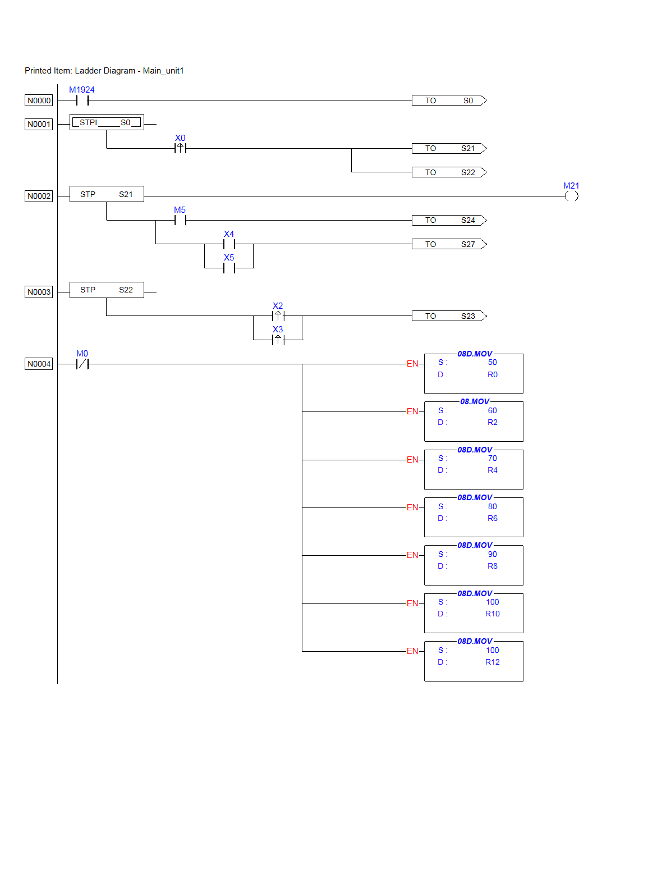
Figure 5.40.A
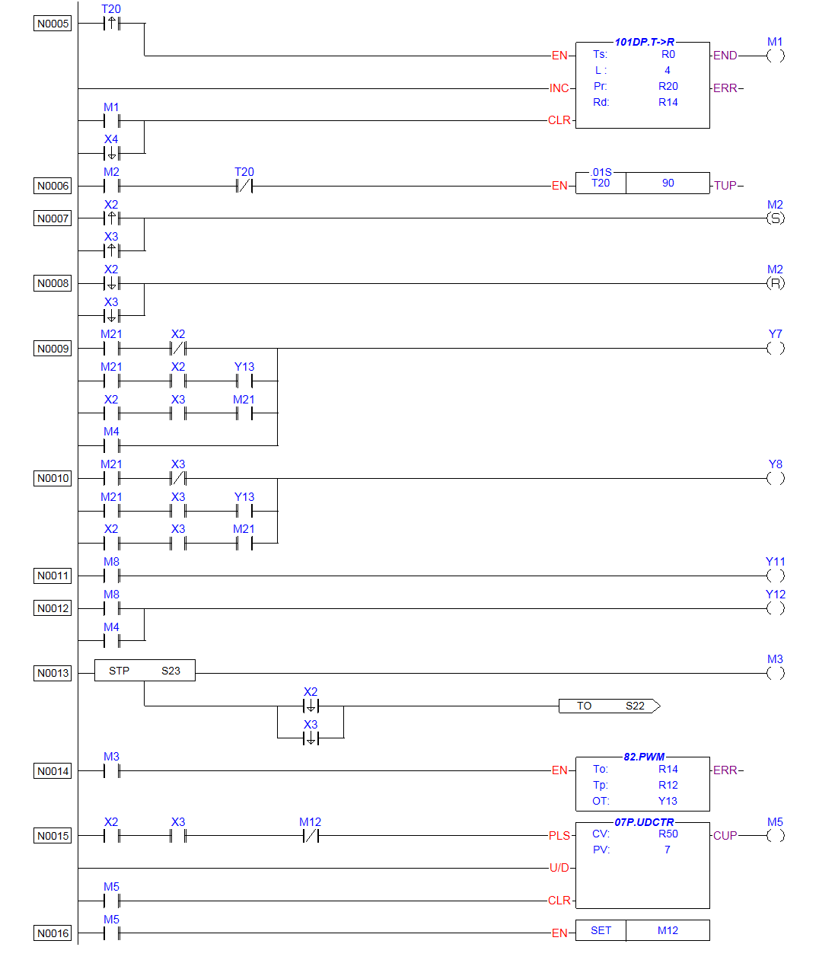
Figure 5.40.B

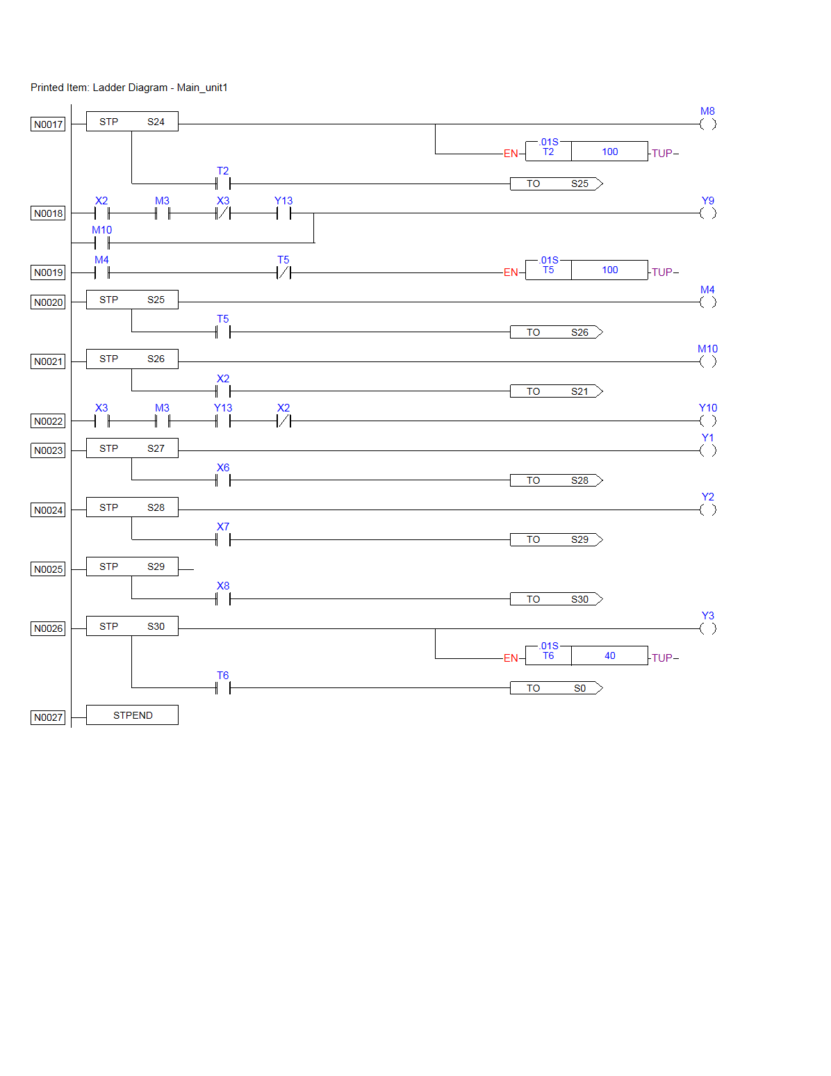
Figure 5.40.C

